**UML Diagrams**

**(UNIFIED MODELING LANGUAGE)**

**Student-Information System**

* The unified modeling language allows the software engineer to express an analysis model using the modeling notation that is governed by a set of syntactic semantic and pragmatic rules.
* A UML system is represented using five different views that describe the system from distinctly different perspective. Each view is defined by a set of diagram, which is as follows.
* **User Model View** 
  + This view represents the system from the users perspective.
  + The analysis representation describes a usage scenario from the end-users perspective.
* **Structural model view** 
  + In this model the data and functionality are arrived from inside the system.
  + This model view models the static structures.
* **Behavioral Model View** 
  + It represents the dynamic of behavioral as parts of the system, depicting the interactions of collection between various structural elements described in the user model and structural model view.
* **Implementation Model View** 
  + In this the structural and behavioral as parts of the system are represented as they are to be built.
* **Environmental Model View** 
  + In this the structural and behavioral aspects of the environment in which the system is to be implemented are represented.

UML is specifically constructed through two different domains they are

* UML Analysis modeling, which focuses on the user model and structural model views of the system.
* UML design modeling, which focuses on the behavioral modeling, implementation modeling and environmental model views.

**USE CASE DIAGRAM:**

**Use case diagrams**: it represents the functionality of the system from a user’s point of view. Use cases are used during requirements elicitation and analysis to represent the functionality of the system. Use cases focus on the behavior of the system from external point of view.

Actors are external entities that interact with the system. Examples of actors include users like administrator, student, faculty…etc., or another system like central database.

**USE-CASE DIAGRAM:**

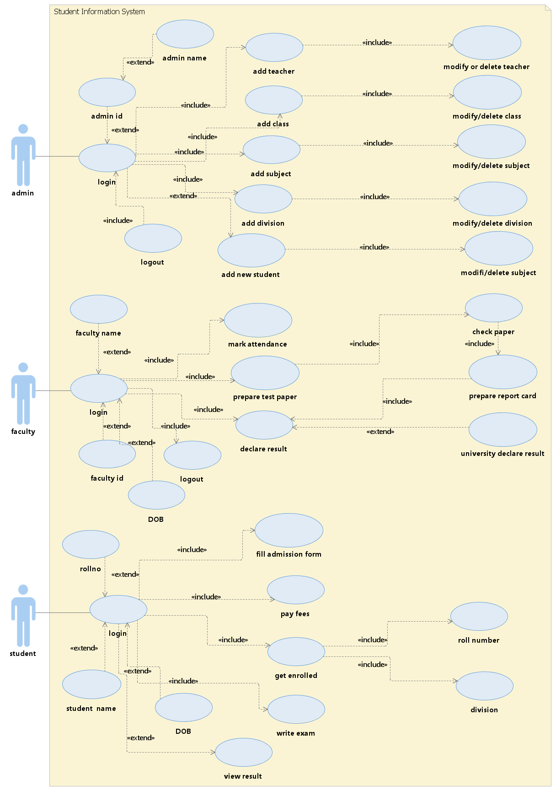

**CLASS DIAGRAM:**

**Class diagram**: The UML class diagram is to illustrate class interfaces and their actions. They are used for static object modeling, we have already introduced and used their UML diagram while domain modeling.

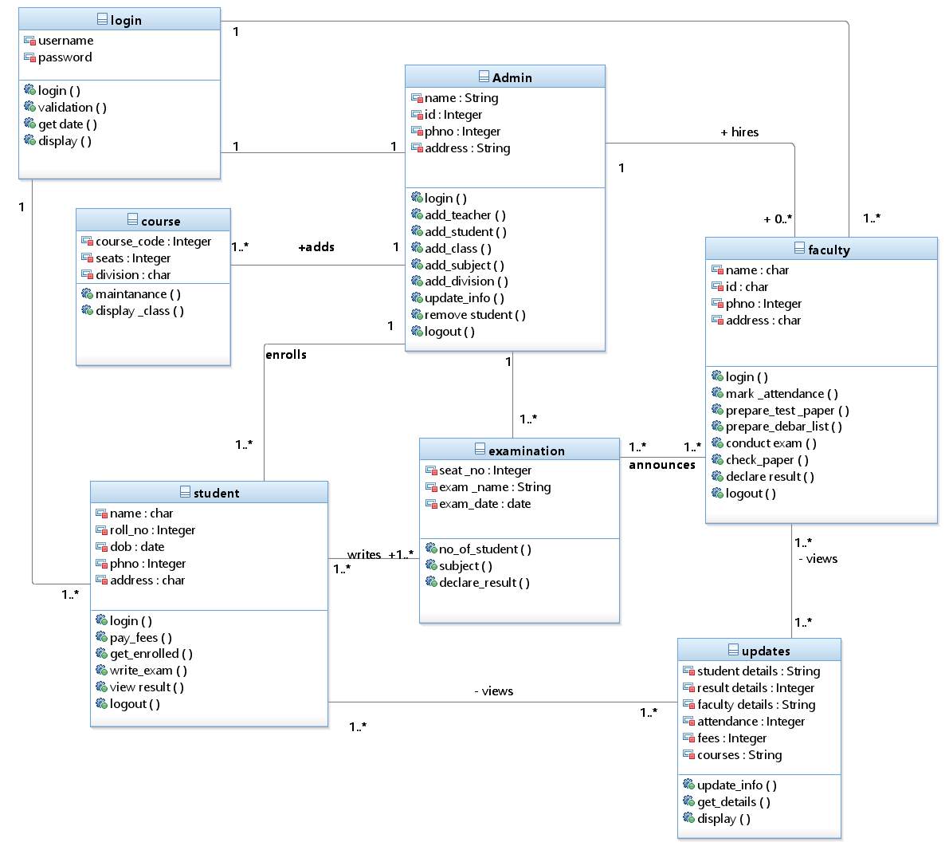

**SEQUENCE DIAGRAMS:**

**Sequence diagram:**A sequence diagram illustrates a kind of format in which each object interacts via message. It is generalize between two or more specialized diagram.

For validation:

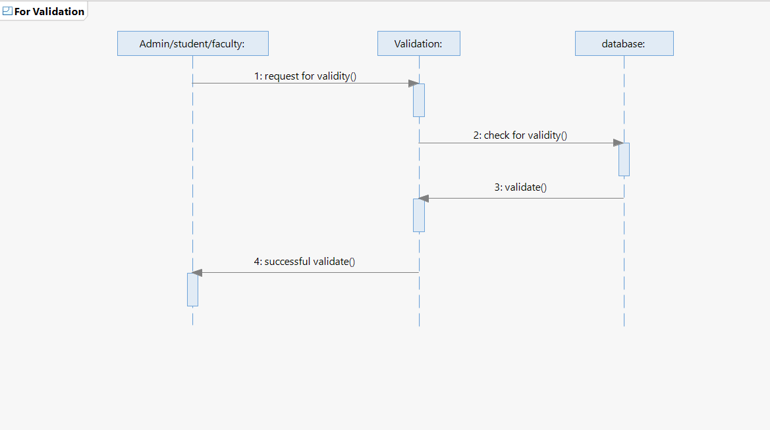

For admin:

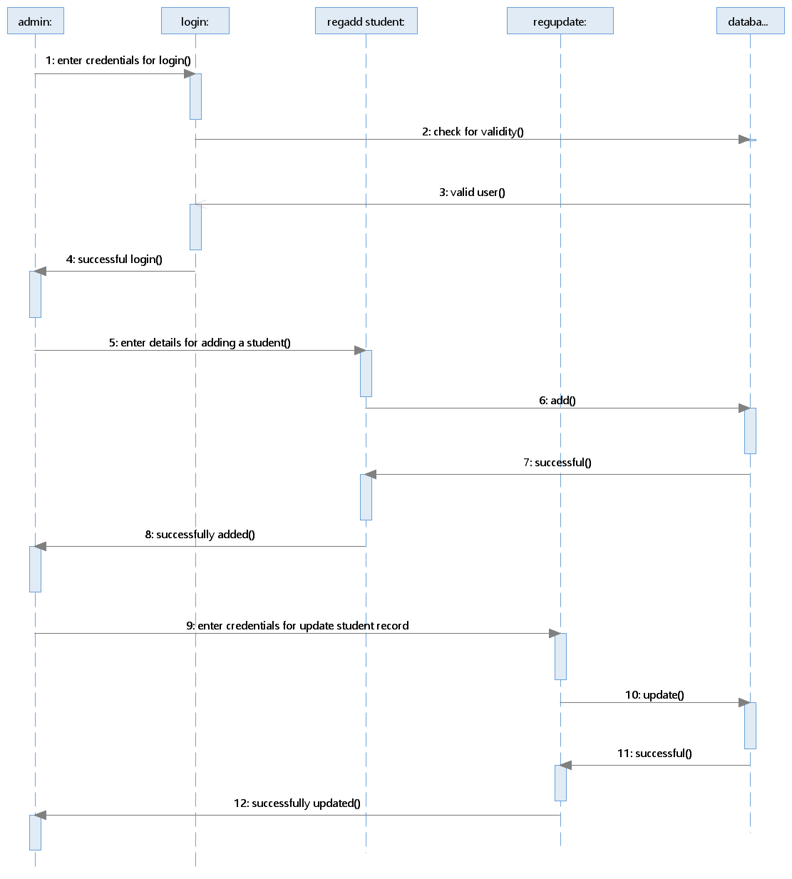

For student/faculty:

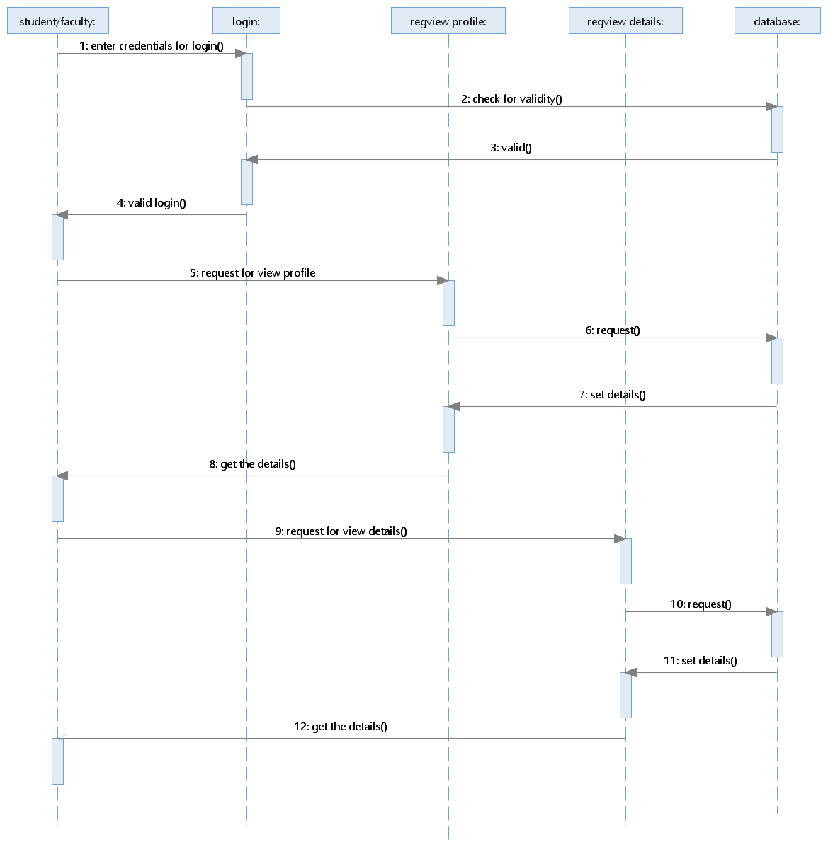­

**ACTIVITY DIAGRAMS:**

**Activity diagram:** It is the graphical representations of workflows of stepwise activities and actions with support for choice, iteration and concurrency. In the Unified Modeling Language, activity diagrams can be used to describe the business and operational step-by step workflows of components in a system. An activity diagram shows the overall flow of control. An activity is shown as a rounded box containing the name of the operation. This activity diagram describes the behavior of the system.

For Admin:

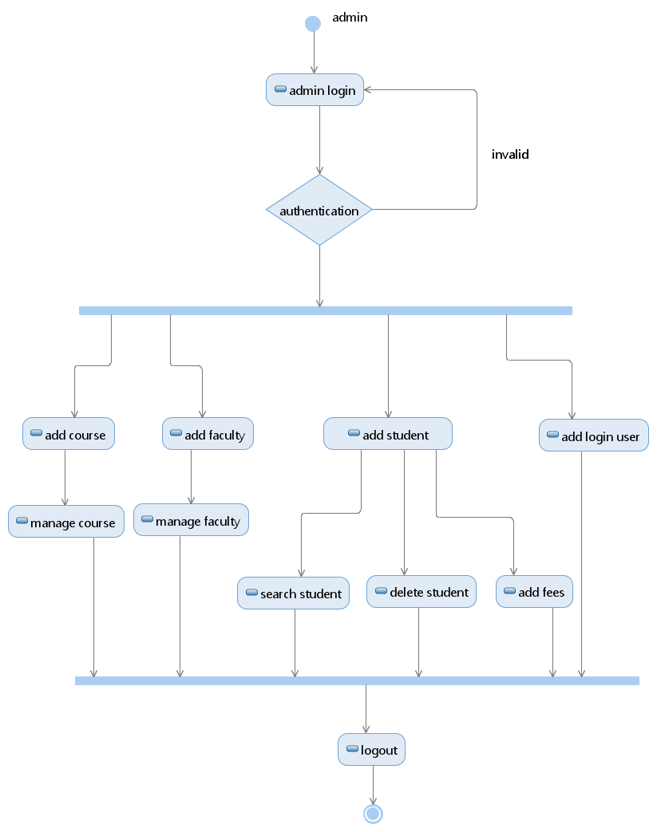

For student/faculty:

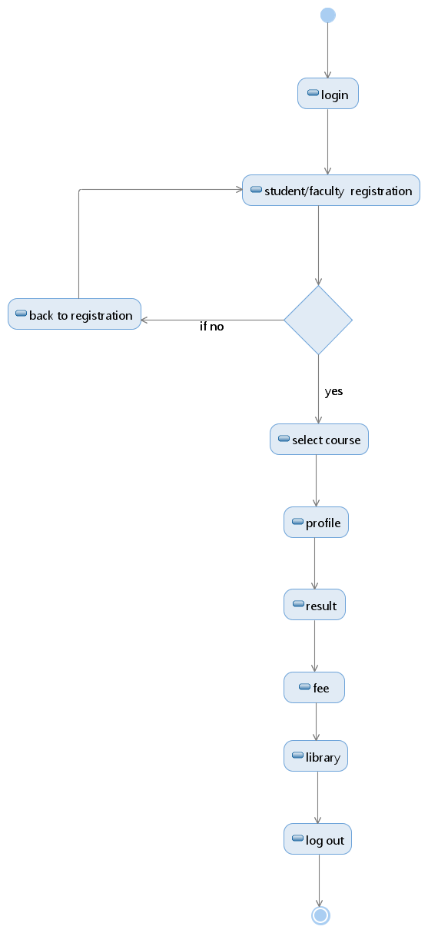

**COLLABORATION DIAGRAMS:**

**Collaboration diagram:**Communication diagram illustrate that object interact on a graph or network format in which object can be placed where on the diagram. In collaboration diagram the object can be placed in anywhere on the diagram. The collaboration comes from sequence diagram.

For validation:

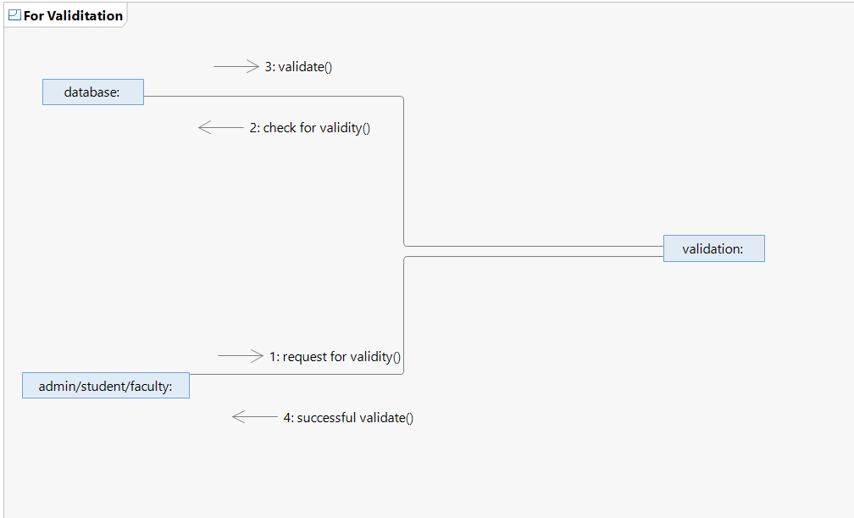

For admin:

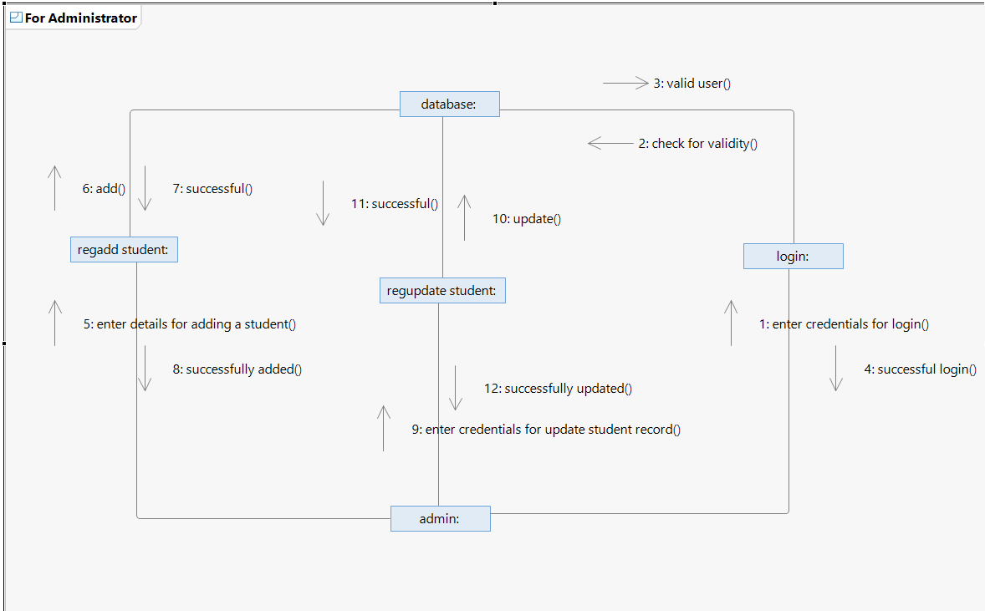

For student/Faculty:

